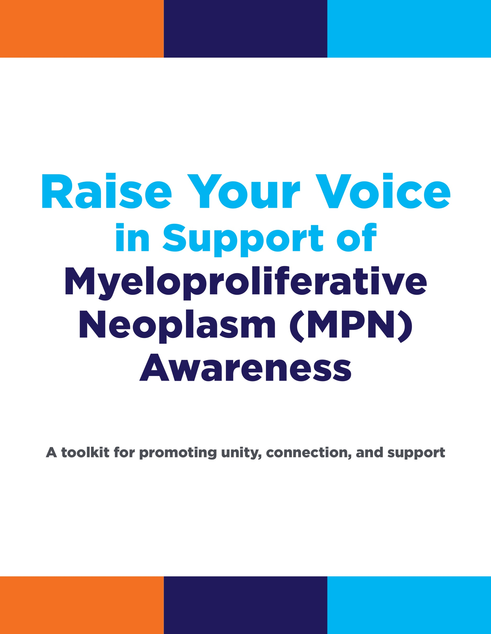

Table of Contents | Page
Introduction |  | 3
The Raise Your Voice toolkit has been developed to help you take action to create awareness of myeloproliferative neoplasms (MPNs). This is particularly important during September, when MPNs are recognized as part of Blood Cancer Awareness Month. The introduction provides information about why awareness is important and how you can participate.
How to Raise your Voice With Social Media |  | 5
Social media is a great way to spread awareness. There are different ways to spread awareness with multiple social media networks. This section serves as a guide on how to use social media with some helpful tips and resources.
How to Engage the Media in MPN Awareness Activities |  | 16
The media is a powerful tool for creating awareness. In this section, you will find guidance on how to engage the media in the most effective way in order to share your story and raise your voice.
How to Form an MPN Team for a Light the Night Walk |  | 20
Many people are invested in efforts to raise awareness and create communities. This section provides you with information on forming a Light the Night Walk team.
Raising Awareness by Recognizing Heroes |  | 22
The MPN Heroes™ Recognition Program acknowledges important individuals and organizations that have made a difference in MPN care. This section offers information about how you can become involved.
Resources for Support |  | 25
There are a growing number of organizations that offer help to individuals with MPNs. This section offers information about the MPN Coalition member organizations’ national and local resources.
MPN Heroes is a trademark of Incyte Corporation.

Introduction
As a person affected by a myeloproliferative neoplasm (MPN), you know about the challenges that living with a rare condition present. You may wonder: Where are the bracelets and ribbons for MPNs? Where is the press coverage of what it is like to live with a rare blood cancer? What can I do to bring more attention to these conditions?
Your actions, with the support of others, can address these questions and drive awareness about MPNs. Raise your voice. Unite with others who are affected by MPNs, and speak out so that your voices are heard and your stories are shared.
The Raise Your Voice toolkit has been developed to help you take action and educate others about MPNs. Taking part in these activities will help to create supportive communities that unite organizations, healthcare providers, patients with MPNs, and caregivers.
How Do I Talk About MPNs?
Raising your voice means educating people who are not familiar with MPNs about what it is like to be affected by these conditions. A simple way to start is by introducing MPNs. MPNs are a group of diseases in which the bone marrow—which produces the body's blood cells—does not function properly. Three types of MPNs include:
- Myelofibrosis (MF)
- Polycythemia vera (PV)
- Essential thrombocythemia (ET)
It’s also important to let people know that most people with MPNs have symptoms that affect their quality of life, but there is hope for people living with these conditions, and this is why raising awareness is so important.
Raising awareness about rare disorders like MPNs can be challenging because:
- There are very few organizations dedicated to the condition
- Patients seeking help sometimes have trouble getting access to medical care
- Many doctors do not have experience diagnosing or treating MPNs. Outside of certain specialists who treat a small number of MPN patients, local hematologists or oncologists may have little, if any, contact with patients who are living with an MPN
As a result, patients with MPNs tend to lack the information they need to understand their condition. They also may not receive the proper treatment or support services they need. That is why it is so important to raise your voice and support activities that increase visibility of MPNs throughout your community.

What Can I Do?
Raise your voice! Become an activist. It doesn’t have to be complicated and it can be fun. Bring together your family members, caregivers, children, or grandchildren, and work together to help promote awareness of MPNs in your community.
The resources in the Raise Your Voice toolkit have been designed to give you the tools you need to host fun, practical activities that can help you, your family, and friends become activists in MPN care.
The MPN Coalition is a group of patient advocacy organizations that was assembled to create awareness of MPNs and enhance education and access to care. With the support of Incyte Corporation, a biopharmaceutical company that specializes in treatments for rare diseases, this toolkit is based upon the version that the MPN Coalition developed to provide you with ideas for how you can bring awareness to your local community.

When Can I Get Started?
Any time! September is Blood Cancer Awareness Month—a fitting time to start spreading the word about how people can make a difference in MPN care. MPN Awareness Day is the second Thursday in September, but volunteers across the country are working to promote activities right now. MPN awareness activities are encouraged at any time and can and should be implemented all year long.
Start by reading through the resources in this toolkit. They have been developed to help inspire you to get up, get out, and speak out. Share your voice with others through simple, fun activities that will help to:
- Educate others in your community about MPNs
- Advocate for better care and support and more treatment options
- Connect with other patients diagnosed with an MPN and caregivers to form an MPN community
These resources are just a starting point. We hope that they will inspire you to think of other ideas not included here that may work for your own MPN awareness activities.

How to Raise your Voice With Social Media

What is social media?
Social media is a way for people to communicate and interact online. It can be a great way to raise your voice and spread awareness about MPNs and connect with others who are also interested in MPNs and rare diseases in general. Social media—including Facebook, Twitter, YouTube, Pinterest, and many others—allows users to engage with each other in a social way, which can include conversations, comments, video, and other user created information.
This section of the toolkit will help you understand the value of social media as a key tool to help raise awareness for MPNs, as well as provide you with resources to help you understand and use some of the more popular social media networks.
What is the value of social media?
The greatest value of social media is your ability to engage with a community of people who have the same interests as you. Engaging in the social media community allows you to interact and have conversations with others. You have the opportunity to connect with people from all over to help raise awareness about MPNs or even rare diseases in general, and can help create a strong advocacy message for MPNs and rare diseases.
Which social network should I sign up for first?
There is no one answer to this question. For every person, this question will be answered differently. Below are some quick guidelines to help you figure out which network is right for you and some tips and guidelines about how to use them.

Facebook
Facebook has become the most widely used social network. From connecting distant friends and family members to bridging the gap between interests and their communities, Facebook is the gold standard for social media. You can access Facebook by visiting www.Facebook.com.
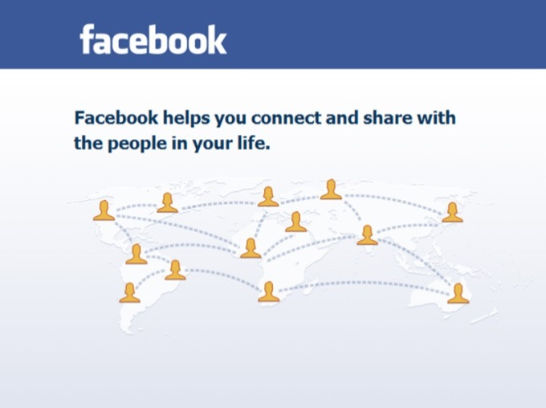
How are people using Facebook?
In addition to posting updates on Facebook, you have the ability to join groups, start your own page for an organization or cause, schedule events, or even talk privately with other users using their messenger services. Sharing stories, videos, photos, and interesting links are all part of the Facebook experience.
Getting started with Facebook
Facebook has an easy step-by-step guide to help you get started.
You can view the Facebook Help Center guide for building your individual page by clicking here:
https://www.facebook.com/help/467610326601639/
Tips and guidelines for using Facebook
Facebook has guidelines for users to follow. Here are some tips to consider when it comes to Facebook.

- Get your friends and family involved: The best resources for learning how to use Facebook are your friends and family members who are already using Facebook. They may have a lot of exposure to Facebook and be able to help you achieve your goals of spreading awareness about MPNs.
- Adding friends and following pages to build an audience: If you are just starting Facebook and want to spread MPN Awareness, then you need an audience to see/read your posts. The best way to engage people is by adding friends, joining groups, or “liking” pages that interest you. The most common reaction to you engaging them is them liking you.
- Ask people to share your posts: Sharing posts is a great way to spread awareness and get your message out there. When someone “shares” your post, all of that person’s friends will be able to see it as well.
- Follow or “like” a page of interest: By following a page that interests you on Facebook, you will be connected with others who “like” the same page, and updates from the page will appear in your timeline. For example, if you are interested in raising awareness about MPNs, you can search and find the “Voices of MPN” Facebook page and “like” it.
Facebook Glossary
Facebook and other social media networks sometimes have their own language. Below is a glossary of terms to help you navigate Facebook.
- Friend (n.): Friends are people you connect and share with on Facebook.
- Friend (v.): The act of connecting with a person you want to add to your Facebook network.
- Groups (n.): Groups are private spaces where you can keep in touch with people by sharing updates, photos or documents.
- “Like” (n.): An engagement function that lets fans give positive feedback on a post.
- “Like” (v.): The act of giving positive feedback on a post.
- Messages (n.): Your messages are like emails inside of the Facebook environment. Your message inbox contains your incoming and ongoing conversations with people on Facebook.
- Newsfeed (n.): Your newsfeed is an ongoing list of updates on your home page that shows what's new with the friends and pages you follow.
- Notifications (n.): Notifications are updates about activity on Facebook.
- Posts (n.): Posts are the status updates, photos, stories, and experiences that tell your story. Posts appear on the timeline section of your profile and may be visible to your friends in their newsfeeds.
- Timeline (n.): Your timeline is where you can see your posts or posts you've been tagged in, displayed by date. Your timeline is also part of your profile.

Twitter
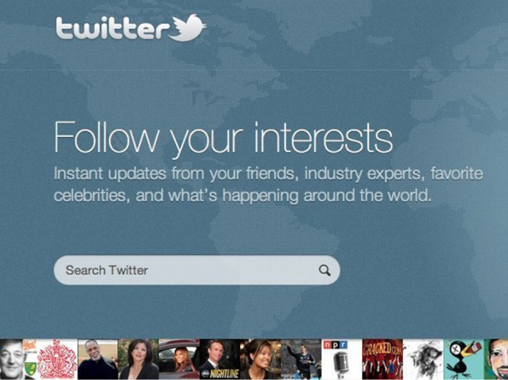
Twitter allows you to send out short messages that are 140 characters or less. This social media tool has helped change the way real-time news and updates are distributed. It is a great way to interact with others who are interested in MPNs. You can access Twitter by visiting www.Twitter.com.
How are people using Twitter?
Twitter allows complete strangers to join together over common interests and participate in conversations by “tweeting,” or posting short messages, to the people who follow them.
Getting started with Twitter
Twitter has an easy guide to help get you started.
You can view the basics for Twitter by clicking here:
https://support.twitter.com/articles/215585
Tips and guidelines for Twitter
Twitter suggests “best practices” to follow in order to be successful. Here are some tips to consider when it comes to Twitter:
- Find people and organizations to follow: A great way to follow along with an organization is to find their Twitter page. By “following” them, you are able to see all of their updates on your timeline.
- Follow people/organizations to build an audience: If you are just starting out with Twitter and want to spread MPN awareness, you need an audience to see/read your posts. The best way to engage people is by following other users. The most common reaction to you following them is them “liking” you.
- “Retweet” (RT) posts that interest you—that you want to share: Retweeting is important because it allows you to share relevant or interesting content with your followers and it also lets the person/organization that you are retweeting know that you find their tweet important.
- Share your thoughts: Whether it’s a quick thought or sharing a link to a website, posting tweets regularly is a great way to share what you think is interesting. If others find it interesting, you will start to add more followers. Building your audience is important because you want to raise your voice to as many people as possible.

Twitter Glossary
Twitter and other social media networks sometimes have their own language. Below is a glossary of terms to help you navigate Twitter.
- Favorite (v.): The act of tapping the star icon to favorite a Tweet. The author of that Tweet will see that you liked it.
- Feed (n.): This is the first thing you see when you log in to Twitter. New posts from your followers are placed in your feed.
- Follow (v.): Subscribing to a Twitter account is called “following.” To start following, click the Follow button next to the user name or on their profile page to see their Tweets as soon as they post something new. Anyone on Twitter can follow or unfollow anyone else at any time, with the exception of blocked accounts. See "block."
- Follower (n.): A follower is another Twitter user who has followed you to receive your Tweets in their home stream.
- Hashtag (n.): A hashtag is a way of indexing or organizing Tweets by subject matter or relevance. A hashtag is any word or phrase immediately preceded by the # symbol. When you click on a hashtag, you'll see other Tweets containing the same keyword or topic.
- Reply (n., v.): A response to another user's Tweet that begins with the @username of the person you're replying to is known as a reply. Reply by clicking the "reply" button next to the Tweet to which you'd like to respond.
- Retweet (RT) (n.): A Tweet that you forward to your followers is known as a Retweet. Often used to pass along news or other valuable discoveries on Twitter, Retweets always retain original attribution.
- Retweet (RT) (v.): The act of sharing another user's Tweet to all of your followers by clicking on the Retweet button.
- Tweet (n.): A post on Twitter is called a tweet; it may contain photos, videos, links, and up to 140 characters of text.
- Tweet (v.): The act of sending a Twitter Message or Tweet. Tweets get shown in Twitter timelines or are embedded in websites and blogs.

YouTube
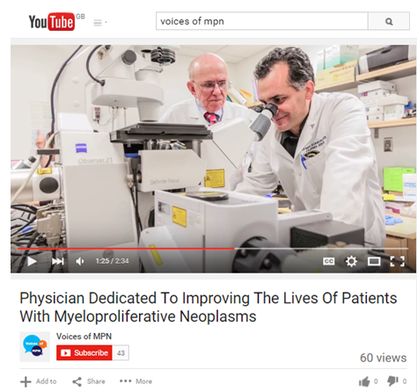
YouTube has been around for over a decade and is most popular for sharing videos on the Internet. In addition to being the most popular place to find interesting videos, it also serves as the second largest search engine after Google. You can access YouTube by visiting www.YouTube.com.
How is YouTube being used?
YouTube is a place to share videos. Videos posted on YouTube can range from professional music videos to simple videos taken by a mobile phone. It is a great outlet for people to share their stories via video – giving a more personal and visual feel.
Getting started with YouTube
YouTube has an easy guide to help you get started.
You can view a step-by-step guide for YouTube by clicking here:
https://www.youtube.com/yt/advertise/en-GB/get-started.html
Tips and guidelines for YouTube
Here are some tips to consider when it comes to YouTube:
- Sharing your story by uploading a video: Use a video camera or even just the video feature on your mobile phone to tell your story on YouTube.
- Favoriting and subscribing: If you favorite a video, it also shows up on your profile page as a video you favorited, sharing it with your friends and subscribers. Subscribing to someone's channel means that you'll see all of their latest uploads and favorites in the feed on your page. This is the equivalent of following someone on Twitter.

YouTube Glossary
YouTube and other social media networks sometimes have their own language. Below is a glossary of terms to help you navigate YouTube.
- Channel or Channel Page (n.): A channel is the public page for a user account on YouTube. It contains uploaded videos, playlists, liked videos, favorited videos, channel comments, and general activity. Some creators manage or create content across multiple channels.
- Favorite (v.): A user action that adds a video to their channel’s Favorites playlist. This action can also be broadcast to subscribers.
- Feed (n.): A stream of activity either for one channel (via the channel page feed) or for multiple channels (the home page feed). Feed activities include uploads, updated playlists, video comments, channel comments, new subscriptions, bulletins, likes, favorites and sharing. Users control what feed activities they broadcast and, by subscribing to channels, what feed activities are broadcasted to them in their homepage feed.
- Share (v.): Ability to distribute videos via social media, email or direct links. This action can be broadcast to subscribers.
- Subscriber/Subscription (n.): By subscribing to a channel, users will see that channel’s activity in their home page feed. Subscribers can also opt into email communication from subscribed channels on a per-upload and weekly digest basis.

Pinterest
Pinterest provides a way for users to simply share and create image collections. It's like a personal bulletin board where you can pin things of interest like recipes, home décor, or art. This social network has grown quickly and it serves as a visual bookmarking tool that helps you discover and save creative ideas. You can access Pinterest by visiting www.Pinterest.com.
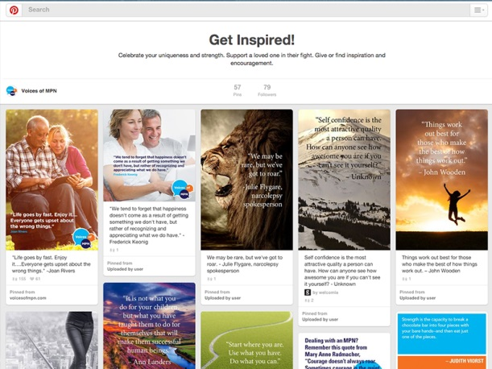
How are people using Pinterest?
Pinterest is a place where you can save, mark, classify, and store information you find online. It allows you to see, comment on, and borrow the things other people save, and vice versa. Pinterest is primarily for images (videos, too, but images are more common).
Getting started with Pinterest
Pinterest has an easy guide to help you get started.
You can view a step-by-step guide for Pinterest by clicking here:
https://help.pinterest.com/en/guide/all-about-pinterest
Tips and guidelines for Pinterest
- Share by pinning: Sharing other people's images and videos is the key concept of Pinterest. Finding images that relate to your interests and pinning them on your boards is the general practice of Pinterest.
- Change captions: Repinning isn't like retweeting on Twitter. You'll want to be sure to update the caption on a repinned pin to personalize it and make it your own.
- Keep organized: Keep your boards organized, as people will follow them for specific content. A user who subscribes to a "dogs and cats" board doesn't want to see images of food or luxury cars. If you want to share new types of content, create new boards. For example, you can create a board that shows images that help educate people on MPN diseases.

Pinterest Glossary
Pinterest and other social media networks sometimes have their own language. Below is a glossary of terms to help you navigate Pinterest.
- Pins (n.): An image that is uploaded (“pinned”) from any web page or your own computer to a Pinterest board. All pins link back to their original source, so make sure you choose the right web page and add a personal description to the pin.
- Pinner (n.): The person or account behind the pins.
- Repin (v.): The act of sharing someone else’s pin.
- “Like” (v.): This functions just as a Facebook “like” or a Twitter “favorite” does. It tells the pinner you enjoyed what they pinned.
- Board (n.): A grouping of pins under a category that you created. It allows you to organize your thoughts, images, and websites in a way that is personal.
- Mention (v., n.): Just like on Twitter, Facebook, and LinkedIn, you can mention another pinner in a post. They will also get a notification about the pin.
- Follow (v.): The act of following other pinners or just a couple of their boards. They do not have to follow you back for you to be able to follow them.

Blogging
A blog is short for weblog. It is a type of website journal or diary to chronicle and share thoughts and information.
How are people using blogs?
Every blog has its own focus. Some are run by individuals, some by organizations. There are blogs that cover just about every topic, allowing people and organizations to have their own website to share thoughts, opinions, and information.
How can you utilize a blog to raise awareness?
A blog is your opportunity to share important thoughts and information.
You can raise your voice and build an MPN online community by blogging. Don’t be afraid to share your knowledge and opinions! It’s an important forum for you to express yourself and hear from others. Listing some standards or guidance for your blog community sets expectations up front and helps create an environment where your audience can learn and grow.
It’s also important to have a constant presence and revise or update your blog in a timely manner in order for it to be successful. Find your MPN voice and share it with others in your blog in a consistent and responsible manner.
Blogging platforms
Here are a few platforms to help you get blogging:
- WordPress: One of the most popular blogging platforms is a free tool that can be hosted either on WordPress or on another domain of your choice. Incredibly flexible and easy to use, it is often the default option for both advanced and novice bloggers. Get started on WordPress by visiting www.wordpress.com.
- Blogger: A free blogging platform built by Google. This tool is quite similar to WordPress but without many of the features and flexibility. Blogs here can either be self-hosted or left on blogger.com. It's much better suited for a casual personal blogger who prefers simplicity. Get started on Blogger by visiting www.blogger.com.
- Tumblr: Tumblr is a microblogging platform and social networking website that allows users to post multimedia and other content to a short-form blog. Users can follow other users' blogs as well as make their blogs private. Many of the website's features are accessed from the "dashboard" interface, including the option to post content and posts from “followed” blogs. Get started on Tumblr by visiting www.tumblr.com.

How to Engage the Media for MPN Awareness Activities

How to Engage the Media in MPN Awareness Activities
One way that you can help to raise awareness is to share your personal story through the media (newspapers, television, radio). Journalists often write public interest stories about how people cope with certain conditions. These stories help increase visibility among the public, patient and professional communities.
By sharing your story you can:
- Advocate for better treatment and care
- Educate your family, friends, local community, and healthcare providers about MPNs
- Provide support and inspiration to other patients with MPNs and caregivers
- Create a close-knit community of patients with MPNs and caregivers
A Step-by-Step Approach to Engaging the Media
Step 1: Identify media representatives from your local newspaper, radio, or television stations to approach about MPN awareness activities. Before sending any materials, identify the person most likely to broadcast your story to the public.
Step 2: Contact the person you have identified to have a preliminary discussion about
- Raising MPN awareness—what it is and why it is important
- Any newspaper, radio, and/or television station policies for broadcasting announcements to the public. You should also discuss
  - Who should receive the materials
  - What is the timeline for broadcasting the materials
  - How you should follow up, and with whom
- Send a thank you note that briefly describes what you learned from the conversation
Step 3: Choose the best person to whom you can make a direct request; this may or may not be the individual you spoke to earlier. Next, follow up as suggested by your contact.

What information should I convey to the media?
Reach out to the media to share your story. As someone living with an MPN or caring for someone with an MPN, you have an important story to tell. Many people, including the media, are not familiar with MPNs. It is important to let them know what MPNs are and that most patients with MPNs have symptoms that affect their quality of life.
The media are most interested in compelling stories about real people who have faced and overcome challenges and are on a mission to help others. Reporters may be interested in hearing your personal experience and perspectives on the following questions
- How were you diagnosed? What are the symptoms of MPNs, and which ones did you have when you were diagnosed? How can someone find out if he or she has an MPN?
- What is it like living with a rare disease like an MPN? What is the nature of the illness? Which symptoms are most difficult to live with? What limitations does an MPN impose on a person’s daily life?
- How does an MPN affect a person’s well-being? How does the illness affect the patient, family, and caregiver? How does it impact their ability to work and social life?
How can I identify the media who might cover my story?
The reporters most likely to cover your story are those who report on health issues in your local newspapers, magazines, or television and radio stations. Call these media outlets and ask for these reporters’ names and contact information (phone numbers and email addresses); keep a list to reference.
How can I get my story to my local media?
- Call reporters and offer to make an appointment to meet with them. During the meeting, be sure to
- Tell them about MPNs and explain what they are
- Talk about your personal experience with MPNs
If reporters would prefer you send them materials rather than meeting with them in person (they usually do), you should
- Follow up to make sure they got the information
- Explain your personal connection to this issue
- Offer to answer any questions they may have

What are some ways to make my story more attractive to the media?
There are a number of ways you can help encourage the media to pay attention to your story and to the activity you are hosting. You can
- Share your personal experiences of living with an MPN or caring for a loved one with an MPN
- Provide the media with an explanation of the science of MPNs (for more information see resources at the end of this toolkit)
- Host an MPN awareness event in your local community and invite the media to cover the story
Remember to use social media to raise awareness!
Facebook:
- “Friend” local thought leaders and media on Facebook or “like” the organization’s page
- Post links to relevant news stories about MPNs and any news stories that you successfully had published on your personal Facebook page
- Post updates on MPN awareness activities in your community
- Use the Voices of MPN™ logo as your profile picture
Twitter:
- Write and send a tweet (message) that is 140 characters or less about:
  - Your experiences living with an MPN or caring for a loved one with an MPN
  - Local activities you are hosting or participating in to raise MPN awareness
  - Relevant news stories or MPN awareness activities
- Use the hashtag #MPNAD
  - A hashtag (#) marks key words or topics in a tweet
  - The hashtag (#) will categorize tweets so they are easily found by others
  - When someone clicks on your hashtagged word they will see all other tweets marked with that keyword

How to Form an MPN Team for a Light the Night Walk

How to Form an MPN Team for a Light the Night Walk
Each year, in communities all across the United States and Canada, teams of families, friends, coworkers, and local and national corporations come together for The Leukemia & Lymphoma Society's (LLS) Light the Night Walks. These events bring help and hope to people battling blood cancers.
LLS provides information and resources for people with MPNs and partners with the MPN Research Foundation to help increase research for MPNs. That is why these walks are a natural fit for those interested in raising awareness of MPNs and contributing to a meaningful cause.

Step-by-Step Approach to Organizing this Event
Step 1 (team leader): Consider why you want to build a team. Creating an MPN team for a Light the Night Walk will help achieve a number of goals, including
- Building support and awareness of MPNs among your community, family, healthcare providers, and friends
- Creating MPN awareness among the patients, caregivers, friends, healthcare providers, and others who participate in Light the Night Walks
- Developing a network of people interested in learning more about MPNs and supporting MPN research and awareness
Step 2 (team leader): Create a team
- Find out when the event will be held in your area at the Light the Night Web site (www.lightthenight.org)
- Create a team name and register your team
- Invite family, friends, neighbors, other patients, and caregivers to join your team
- Sign up for updates and helpful hints
- Ask to post notices in your doctor’s office, hospital, or clinic
- Ask local businesses to participate by walking with your team or donating to the cause
- Have fun—create MPN awareness T-shirts for your team
- Send out a press release (see Section 1.3, Sample MPN Awareness Press Release, for more information)

Raising Awareness by Recognizing Heroes

How to become involved in the MPN Heroes Program
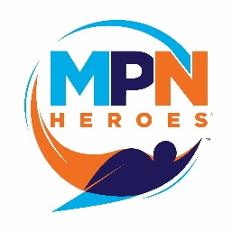
In the spirit of recognizing those individuals and organizations that contribute to the MPN community, and in alignment with the MPN Coalition’s goal to further build the community, Incyte Corporation, in collaboration with CURE Media Group, publishers of CURE magazine, is sponsoring the MPN Heroes Recognition Program. This program is an opportunity to acknowledge dedication to MPN care and to increase visibility for the MPN community. An additional opportunity for recognition is the Wall of Voices, a virtual wall available for posting photos and stories of MPN heroes.
Anyone can nominate an MPN Hero. A hero can be an individual (eg, patient, caregiver, doctor, nurse) or organization (eg, medical practice, advocacy group, medical center). For more information and to nominate your MPN Hero today, visit www.MPNHeroes.com.
You can nominate your hero in one of two categories:
- Commitment to the individual, which recognizes individuals who provide or demonstrate care, guidance, education, or support above and beyond the standard of care for one or more patients with MPNs. Recipients will receive a plaque to recognize their dedication
- Commitment to the broader MPN community, which recognizes leadership in developing services and programs addressing needs of patients with MPNs, families, friends, caregivers, and medical professionals through advancing the science and medical understanding of MPNs, education, awareness, or approaches to care. Donations of $25,000 will be made by Incyte to a nonprofit 501(c)(3) US-based organization or society that provides help to people with MPNs
To spread the word about MPNs and the people involved in the community, there are multiple ways for you to be involved
- Nominate an individual or an organization for MPN Hero recognition
- Raise awareness about MPNs and the MPN Heroes Program through other activities described in this toolkit
- Celebrate previous winners and nominees by sharing the heroes page on Facebook and Twitter: See the icons in the upper right at www.MPNHeroes.com
- Submit your story online at www.MPNHeroes.com
- Share awareness ribbons and bracelets with friends and family (see below)
For more information on the nominating process, visit www.MPNHeroes.com. This Web site also contains information and videos about the achievements of past recipients. We hope that these stories will inspire you and bring to mind others worthy of MPN Heroes recognition.
Nominations will be collected through MPN Awareness Day. The recipients will be announced at the MPN Heroes Celebration Event, hosted by CURE Media Group. This event will take place at the American Society of Hematology Annual Meeting and Exposition.
You can also register for MPN updates and resources, including ribbons and bracelets at www.VoicesofMPN.com/myeloproliferative-awareness-tools. Share these ribbons and bracelets with your friends and family to let them know of the event, the Web site, and the great accomplishments of those selected as MPN Heroes.

Resources for Support
MPN Coalition Members
Organization name | Contact information
CancerCare  CancerCare is the leading national organization committed to improving lives by providing professional services to help people manage the emotional and financial challenges of cancer. CancerCare’s comprehensive network of services includes telephone, online, and in-person counseling and support groups, education, publications, resources, and financial and co-payment assistance. All CancerCare services are provided by professional oncology social workers and are completely free of charge. | 275 Seventh Avenue  New York, NY 10001  (800) 813-HOPE (4673)  info@cancercare.org
Cancer Support Community (CSC)  The Cancer Support Community is an international non-profit organization dedicated to providing professional support, education, and hope face to face, online, and over the phone to people affected by cancer. Its global network brings the highest quality cancer support to the millions of people touched by cancer so that no one has to face cancer alone. | 1050 17th Street, NW  Suite 500  Washington, DC 20036  (888) 793-9355  help@cancersupportcommunity.org
MPN Advocacy and Education International (MPN A&EI)  MPN Advocacy and Education International is dedicated to providing the knowledge, support, and resources patients with myelofibrosis, polycythemia vera, and essential thrombocythemia will need as they adjust to living with an MPN. This is done through educational symposia in several cities each year; Web site access, free webcasts of each program; collateral materials and direction to people, resources, and other organizations that can help. | (517) 899-6889  abrazeau@mpnadvocacy.com
MPN Education Foundation  A non-profit organization run by volunteer patients with MPNs, the MPN Education Foundation was developed to advance research and knowledge about MPNs and improve the quality of life and care of patients with MPNs.  Affiliated MPN-NET provides daily online support, education, and resources to patients and their families/caregivers. | jahjerpe@sbcglobal.net
MPN Research Foundation  The mission of the MPN Research Foundation is to stimulate original research in pursuit of new treatments—and eventually a cure—for MPNs. The Foundation promotes collaboration in the scientific community to accelerate research and serves as a powerful advocacy group for patients and their families. | 180 North Michigan Avenue  Suite 1870  Chicago IL 60601  (312) 683-7249  mwoehrle@mpnresearchfoundation.org
National Organization for Rare Disorders (NORD)  NORD is a unique federation of voluntary health organizations dedicated to helping people with rare “orphan” diseases and assisting the organizations that serve them. NORD is committed to the identification, treatment, and cure of rare disorders through programs of education, advocacy, research, and service. | 55 Kenosia Avenue  Danbury, CT 06810  (203) 744-0100
The Leukemia & Lymphoma Society (LLS)  As the world’s largest voluntary health agency dedicated to blood cancer, LLS funds lifesaving blood cancer research around the world and provides free information and support services. Its mission is to cure leukemia, lymphoma, Hodgkin’s disease and myeloma, and improve the quality of life of patients and their families. | 1311 Mamaroneck Avenue, Suite 310  White Plains, NY 10605  (800) 955-4572  infocenter@lls.org

CancerCare, Cancer Support Community (CSC), MPN Advocacy and Education International (MPN A&EI), and MPN Research Foundation (MPN)
Affiliates by State
The above organizations have local affiliates where you can also find help and support.
State | Affiliates
Arizona | CSC  - Phoenix: Cancer Support Community—Arizona, info@twccaz.org or (602) 712-1006
California | CSC  - Palm Desert: Gilda’s Club Desert Cities California, gcdinfo@dc.rr.com or  (760) 770-5678  - Los Angeles: Cancer Support Community Santa Monica (Benjamin Center), info@cancersupportcommunitybenjamincenter.org or (310) 314-2555  - Pasadena: Cancer Support Community Pasadena, (626) 796-1083  - Paso Robles: Cancer Support Community California Central Coast, (805) 238-4411  - Redondo Beach: Cancer Support Community Redondo Beach, info@wellnessandcancer.org or (310) 376-3550  - Walnut Creek: Cancer Support Community San Francisco Bay Area,  (925) 933-0107  - Westlake Village: Cancer Support Community Valley/Ventura/Santa Barbara, twcinfo@wellnesscommunityhope.org or (805) 379-4777  MPN/MPN A&EI  - Los Angeles: Ron Anderson, randerson@activetech.com  - San Diego: Antje Hjerpe, jahjerpe@sbcglobal.net  - San Francisco: Susan Klepper, Susanklepper@hotmail.com
Colorado | MPN/ MPN A&EI  - Denver: Mabel Peters, mabel.d.peters@kp.org
Connecticut | CancerCare  - Sandra Tripodi: (203) 854-9911  CSC  - Branford: (203) 483-4227
Delaware | CSC  - Dover: Kent County Office, (302) 734-0898  - Rehoboth Beach: Sussex County Office, (302) 645-9160  - Wilmington: Cancer Support Community Delaware, (302) 995-2850
Florida | CSC  - Fort Lauderdale: Gilda’s Club South Florida, (954) 763-6776  - Miami: Cancer Support Community Greater Miami, (305) 668-5900
Georgia | CSC  - Atlanta: Cancer Support Community Atlanta, (404) 843-1880  MPN/MPN A&EI  - Atlanta: Bonnie Evans, kbemje@bellsouth.net or (404) 771-0010
Hawaii | MPN/MPN A&EI  - Oahu: Albert Loo, looa002@hawaii.rr.com
Idaho | MPN/MPN A&EI  - Boise: Susan Hill, jacksue@cableone.net
Illinois | CSC  - Chicago: Gilda’s Club Chicago, (312) 464-9900  MPN/MPN A&EI  - Chicago: Michelle Woehrle, mwoehrle@MPNResearchFoundation.org or  (312) 683-7243
Indiana | CSC  - Evansville: Gilda’s Club Evansville, mmforston@gmail.com or (812) 402-8667  - Indianapolis: Cancer Support Community Central Indiana, (317) 257-1505  MPN/MPN A&EI  - Bloomington: Ellen, hankandellen@bluemarble.net
Iowa | CSC  - Davenport: Gilda’s Club Quad Cities, Claudia@gildasclub.org or (563) 326-7504
Kentucky | CSC  - Louisville: Gilda’s Club Louisville, info@gildasclublouisville.org, (502) 583-2004  MPN/MPN A&EI  - Susan Kennedy, smkennedy0@gmail.com
Massachusetts | CSC  - Norwell: Cancer Support Community Massachusetts South Shore, (781) 610-1490  MPN/MPN A&EI  - Massachusetts & Greater New England: silverlady3@gmail.com or mpdnewengland@gmail.com
Michigan | CSC  - Ann Arbor: Cancer Support Community Greater Ann Arbor, (734) 975-2500  - Grand Rapids: Gilda’s Club Grand Rapids, info@gildasclubgr.org or  (616) 453-8300  - Royal Oak: Gilda’s Club Metro Detroit, (248) 577-0800  MPN/MPN A&EI  - Lansing: Ann Brazeau, abrazeau@MPNResearchFoundation.org
Minnesota | CSC  - Minneapolis: Gilda’s Club Twin Cities, (612) 227-2147
Missouri | CSC  - Kansas City: Gilda’s Club Kansas City, (816) 531-5444  - St. Louis: Cancer Support Community Greater St. Louis, info@cancersupportstl.org or (314) 238-2000
Montana | CSC  - Bozeman: Cancer Support Community Montana, (406) 582-1600
New Jersey | CancerCare  - Kathy Nugent: (201) 444-6630  CSC  - Bedminster: Cancer Support Community Central New Jersey, (908) 658-5400  - Linwood: Gilda’s Club South Jersey, info@gildasclubsouthjersey.org or  (609) 926-2699
New Mexico | MPN/MPN A&EI  - Albuquerque: abq_mpn@yahoo.com
New York | CancerCare  - National Office: (800) 813-HOPE  - Long Island: Win Boerckel: 516-364-8130  CSC  - New York: Gilda’s Club New York City, info@gildasclubnyc.org or (212) 647-9700  - Rochester: Gilda’s Club Rochester, info@gildasclubrochester.org or  (585) 423-9700  - White Plains: Gilda’s Club Westchester, info@gildasclubwestchester.org or  (914) 644-8844  MPN/MPN A&EI  - New York City: Susan Protter, sapla@aol.com or (212) 580-0115
North Carolina | CSC  - Cancer Support Community Eastern North Carolina, admin@cancersupportnc.org or (252) 364-1190  MPN/MPN A&EI  - Janice Creed, jcreed@roadrunner.com
Ohio | CSC  - Cincinnati: Cancer Support Community Greater Cincinnati/Northern Kentucky, info@cancer-support.org or (513) 791-4060  - Columbus: Cancer Support Community Central Ohio, (614) 791-9510  MPN/MPN A&EI  - Akron/Cleveland: Jay Schmitt, ohiompd@sbcglobal.net  - Cincinnati: Rebecca Lubitz, rebeccalub@aol.com or (513) 793-3179
Pennsylvania | CSC  - Bethlehem: Cancer Support Community Greater Lehigh Valley, (610) 861-7555  - Philadelphia: Cancer Support Community Philadelphia, (215) 879-7733  - Warminster: Gilda’s Club Delaware Valley, info@gildasclubdelval.org or  (215) 441-3290  MPN/MPN A&EI  - Philadelphia: Marie, mtomp57083@comcast.net
South Carolina | MPN/MPN A&EI  - Janice Creed, jcreed@roadrunner.com
Tennessee | CSC  - Knoxville: Cancer Support Community East Tennessee, (865) 546-4661  - Nashville: Gilda’s Club Nashville, info@gildasclubnashville.org or (615) 329-1124
Texas | CSC  - Austin: Cancer Support Community Central Texas, (512) 358-9876  - Dallas: Cancer Support Community North Texas, info@cancersupporttexas.org, (214) 219-8877  MPN/MPN A&EI  - Houston: Charlie Nielsen, charlienielsen@aol.com
Utah | MPN/MPN A&EI  - Salt Lake City: Rynda Brown, ryndabrown2006@yahoo.com
Washington | CSC  - Gilda’s Club Seattle, info@gildasclubseattle.org or (206) 709-1400  MPN/MPN A&EI  - Seattle: Seattle MPD Yahoo Group
Wisconsin | CSC  - Middleton: Gilda’s Club Madison Wisconsin, (608) 828-8880  MPN/MPN A&EI  - Racine: Karen Luba, klipluba@yahoo.com or (262) 552-7047

Voices of MPN and MPN Heroes are trademarks of Incyte Corporation. UPM-1036 09/15

